**Indoor and outdoor methods of tracking users via mobile phones.**

**SAMPATH KUMAR MANNE**

**INTRODUCTION:**

In today’s world, personal data is completely stored online. Portable devices like laptops and mobile phones help us to carry this data along with us in real-time with the help of Internet. These portable devices are often Wi-Fi and GPS enabled. In this fast moving world services based on location are becoming an integral part of everyone’s life. To track the geographical location of colleagues and friends using an application in real-time is discussed in this paper.

**Keywords**

Mobile, Wi-Fi, GPS, Tracking, Client, Builder, Server, Receiver

**BACKGROUND:**

Location-based services (LBS) applications are a growing business. We have seen many location based services like Google Maps, Uber, etc., which provide information to users based on their present location. In outdoor systems, GPS-based tracking systems have been in use for many years to identify geographical location of vehicles, navigations and many more. But for indoor systems, GPs-based tracking doesn't give accurate position because it becomes difficult to acquire necessary information from the satellite for computation in a very small area. To reduce the difficulty, one can make use of Wi-Fi or Bluetooth coupled with 3G networks to estimate the location of the device in indoor systems.

**WI-FI:**

Wi-Fi is a local wireless network facility used to connect laptops, mobile phones, and tablets to the Internet. A wireless network uses radio waves for data transfer. A router receives information from the Internet; which is translated into a radio signal by the router. The wireless adapter of the device (laptop/mobile) picks up the radio signal from the adapter and decodes it.

**WIRELESS INDOOR TRACKING SYSTEM**

Indoor wireless systems are of great use for locating devices inside a building. These devices help us to find the location of a person or an infant or a pet inside a campus or a building. These tracking systems are purely software dependent. They consist of an infrastructure that uses WLAN and a sensor using an adapter. It is composed of a server, client, and builder and is implemented using C++.

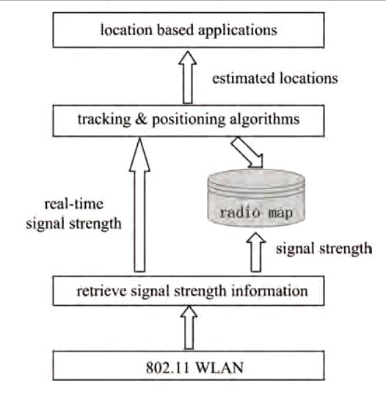

Figure.1: Working steps of WITS [1]

**INFRASRUCTURE:**

**Server**:

WITS use an algorithm to determine the location of a device or a client. Server receives a tracking request from a WITS client; using the tracking algorithm it estimates the real-time location of the device, which should be tracked. The estimated location is sent back to the WITS client for usage.

**Client:**

The client is basically software installed on the mobile device. The received signal strength will request tracking with the WITS server to map the location once it receives a reply from the WITS server. The client also has a feature of who can track his estimated position by registering with the server. It is necessary to build a radio signal strength (RSS) map before tracking the clients. This can be done using WITS builder.

**Builder:**

Builder basically collects samples of radio signal strength at many points inside the building. After collecting the samples, it sends them to the server database, which stores each and every sample and develops the RSS radio map.

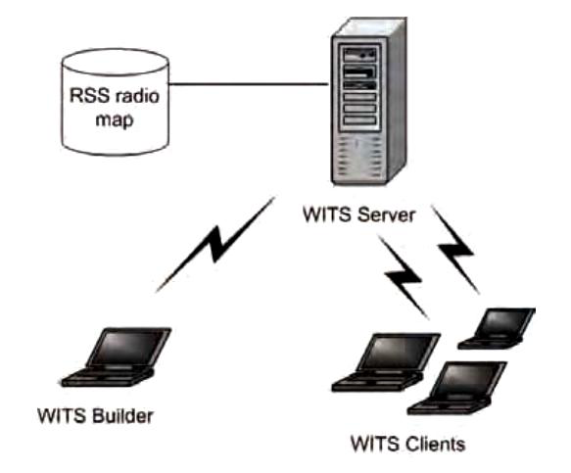

Figure.2: Architecture of WITS [1]

It is important to pick up the right point on the RSS map based on the signal received from the client. WITS algorithms do a very good job in identifying the right point on the map using two ways

1. Deterministic Algorithm
2. Probabilistic Algorithm

**a) Nearest Neighbor Algorithm**

This algorithm gives us a basic idea of deterministic algorithms. We already learned that the builder collects and sends various RSS samples to the server. During this process, the builder is strategically placed at calibrated locations to collect and send the RSS samples. The mean value of the RSS sample at a given location is mapped on the RSS map based on their signal strength. During tracking, the received signal is estimated using the mean values of the RSS maps radio and the nearest location is thus determined.

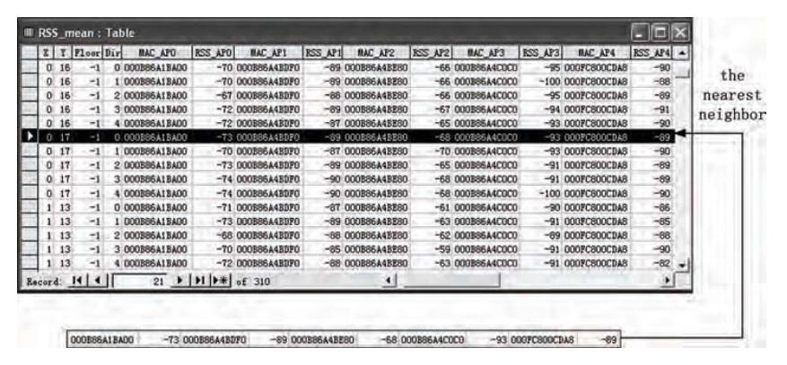

Figure.3: Table of Nearest Neighbor Algorithm [1]

**b) Bayesian Algorithm**

This algorithm gives us an idea about probabilistic algorithms. The calibration phase in this method is similar to nearest-neighbor algorithm. This algorithm uses the law from Bayesian algorithm to pick up the probable position of the client.

**c) History-based tracking algorithm**

History-based tracking algorithm uses a series of consecutive signals. This algorithm helps us to track a person when he is moving in real-time. In contrast with above-mentioned algorithms, HBT algorithm is very favorable when users tend to travel lengthy destinations. This algorithm uses Bayesian algorithm to pick up the probable position of client neighboring point, while using a series of consecutive signals.

Steps to Track a moving person:

* When the device is moving, real-time signal strength should be after fixed intervals [1].
* Use Bayesian algorithm for estimating the nearest ‘k’ neighbors on the RSS map (Predefined parameter k).

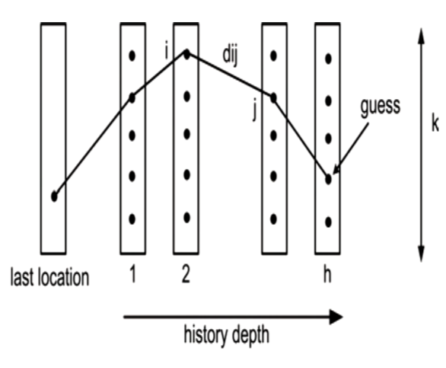

Figure.4: History based tracking system [1]

All the ‘k’ nearest neighbors is arranged in columns, maintaining a fixed history vector of depth ‘h’

* While collecting the consecutive signals, changes are made to the history vector that has ‘k’ depth vectors. The oldest ‘k’ nearest neighbor column is removed and a ‘k’ newest nearest neighbor column is inserted, to maintain ‘h’ (where h is the history vector depth).
* After estimating the ‘k’ newest vector the shortest path is computed. The physical distance is the distance linking the adjacent points.
* The estimated current location of device is always the final point in the shortest path.
* These steps are followed recursively, until the user stops tracking the device.

**WITS Using Bluetooth**

Many Bluetooth access points are setup at known locations, and this information will be updated onto the database in a table called Bluetooth table. To locate users, the client scans for the visible Bluetooth access point. Based on these points, the system discovers the estimated position of the device.

**GLOBAL POSTIONING SYSTEM**

GPS is the circumstance of 27 huge satellites orbiting the globe. These satellites orbit at a distance of about 20k kilometers from the circumference of the globe. Each satellite makes 2 orbit-revolutions in a single day and these revolutions are planed in such a way, where each view from the earth has at most six satellites pointing towards it. This system was developed and implemented by U.S military as a navigation system. But, very soon it was open to many people all over the world without any kind of charge or restrictions.

GPS is vast and expensive, it uses complex technology, but the fundamental concepts are simple. GPS satellites constantly broadcast signals to the earth. Each signal from a satellite transmits the exact location of the satellite and time when it was sent. A GPS receiver in the device receives signals from these satellites and decodes the signals. At least 4 satellite signals are required to determine the coordinates. By deducting the signal time of transmission with received signal, the receiver can estimate the distance of the device from every single satellite. GPS is ideal for outdoor tracking systems such as surveying, farming, transportation or military use.

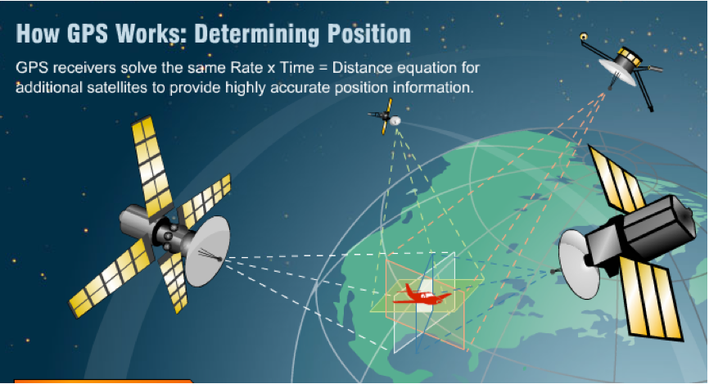

Figure.5: GPS Functionality

**CONCLUSION:**

Usage of Wi-Fi routers is increasing exponentially in closed buildings, hospitals, hotels, universities, trains, parks etc. Usage of Wi-Fi enabled smartphones is also increasing day by day. Both these above-mentioned devices can easily contribute to WITS. Outdoor tracking using GPS is a favorite application for developers all over the world. It has numerous applications to boost local markets, location based services, etc. In today’s world, personal safety of women and children safety are two major concerns. Outdoor tracking and indoor tracking can be used to effectively tackle these problems.

**REFERENCE:**

[1] Atul Gosai. Rushi Raval, “Real Time Location based Tracking using WIFI Signals”,International Journal of Computer Applications (0975 – 8887) Volume 101– No.5, September 2014.

[2] F. Aloul, A. Sagahyroon, A. Al-shami, Al-Midfa, R.Moutassem, “Using Mobiles for On Campus Location Tracking”, American University of Sharjah, Sharjah, UAE.

[3] Katina Michael, Andrew McNamee, MG Michael, “The Emerging Ethics of Humancentric GPS Tracking and Monitoring”, School of Information Technology and Computer Science, University of Wollongong, Australia {katina, am46, mgm}@uow.edu.au.

[4] Radhika Kinage, Jyotshna Kumari, Purva Zalke, Meenal Kulkarni, “Mobile Tracking Application”, Student, Department of Computer Technology, Yeshwantrao Chavan College of Engineering, Nagpur, Maharashtra, India. International Journal of Innovative Research in Science, Engineering and Technology Vol. 2, Issue 3, March 2013.

[5] Sanjay Ahuja, Pavan Potti, “An Introduction to RFID Technology”, School of Computing, University of North Florida, Jacksonville, Florida. Communications and Network, 2010, 2, 183-186 doi: ßs10.4236/cn.2010.23026 Published Online August 2010 ([http://www.SciRP.org/journal/cn](http://www.scirp.org/journal/cn)).